E- commerce sales data
This is an E-commerce sales dataset which contains of 5000+ rows and 12 columns.
Column Names:
- Order_id
- Order_date
- Customer_id
- Product_category
- Region
- Quantity
- Unit_price
- Discount
- Payment_method
- Delivery_days
- Customer_rating
- Revenue
Started working on the dataset: E-commerce sale dataset
Issues: while i was trying to looking at the dataset randomly spotted the difference in date values and so, tried to convert them in date values but it throwed me #value error !
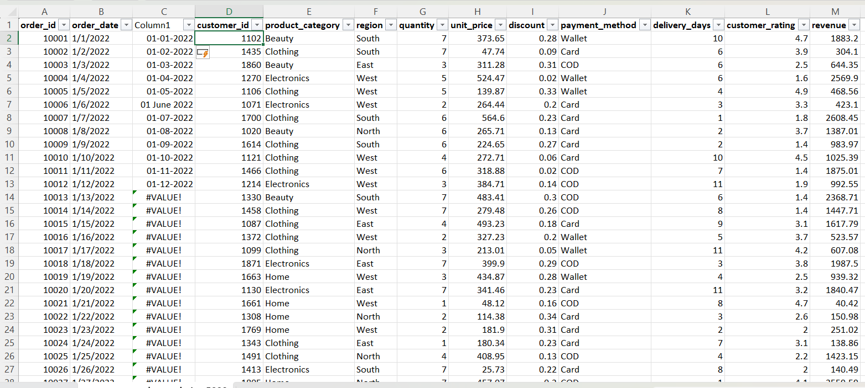
Resolved using: Data-> Text to column: choosing the DMY format worked.
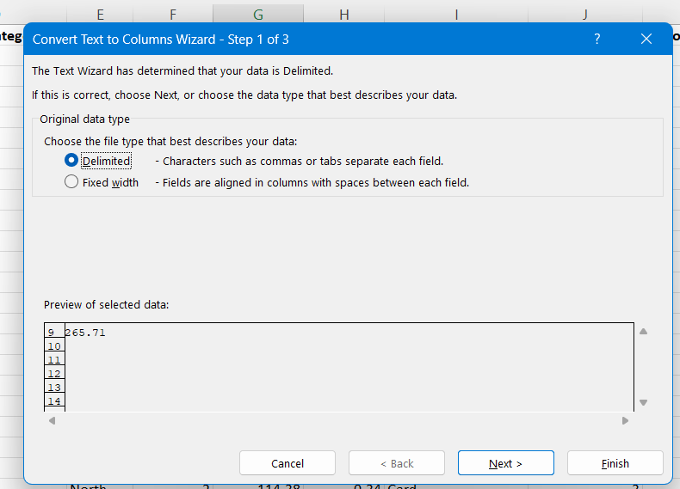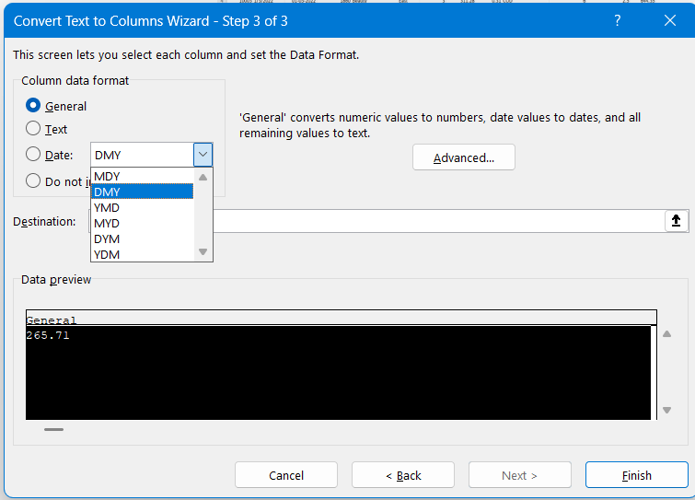

Further, looked the column in the dataset and started analysing it. Found that all the order ID’s were unique but the customer IDs are repeated and have duplicates.
At a transactional level dataset, it is the common understanding that a single customer can place multiple orders.

🧠 1. First — Understand Your Dataset (Like a Real Analyst)
From your file , your dataset has columns like:
- Order ID
- Date / Month
- Customer ID
- Category (Beauty, Clothing, Electronics…)
- Region (North, South…)
- Quantity
- Price
- Discount
- Payment Mode
- Ratings
- Total Value
👉 This is clearly an E-commerce Sales Dataset

🎯 2. How a Modern Analyst THINKS (Before Dashboard)
A beginner thinks:
“What charts can I make?”
A good analyst thinks:
“What business questions should this dashboard answer?”

💡 Step 1: Define the Goal
Ask:
👉 “If I was a manager, what would I want to know?”
For your dataset, the goal is:
“Understand sales performance, customer behavior, and business growth.”

💡 Step 2: Identify Key Metrics (KPIs)
From your dataset:
- Total Revenue
- Total Orders
- Average Order Value
- Total Quantity Sold
- Average Rating
👉 These become your top cards in dashboard

💡 Step 3: Ask Smart Questions (This is KEY)
Here’s how a Microsoft-level analyst thinks 👇
📊 Sales Performance
- Which month has highest revenue?
- Is sales increasing or decreasing?
🛍️ Product Insights
- Which category sells the most?
- Which category gives highest revenue?
🌍 Regional Insights
- Which region performs best?
- Any region underperforming?
💳 Payment Behavior
- Which payment method is most used?
⭐ Customer Experience
- Does higher rating = more sales?
- Which category has poor ratings?
👉 These questions = your dashboard structure

📊 3. How Your Dashboard Should Look (Modern Style)
🔝 Section 1: KPI Cards
- Revenue
- Orders
- Avg Order Value
- Avg Rating

📈 Section 2: Trends
- Line chart → Revenue by Month

📦 Section 3: Category Analysis
- Bar chart → Revenue by Category
- Pie chart → Sales distribution

🌍 Section 4: Region Analysis
- Map / bar → Region vs Revenue

💳 Section 5: Payment Insights
- Donut chart → Payment methods

⭐ Section 6: Ratings Insight
- Scatter plot → Rating vs Revenue

👉 THIS is how modern dashboards are built
👉 Not random charts — story-driven layout

🔍 4. Now — How YOU Should Approach ANY Dataset (Step-by-Step)
This is your repeatable framework

🧩 Step 1: Understand Columns
Ask:
- What is each column?
- Is it numeric / categorical / date?

🧹 Step 2: Data Cleaning
Check:
- Missing values
- Wrong formats (you already faced this 👍)
- Duplicates

🔢 Step 3: Create New Columns
Example:
- Revenue = Quantity × Price
- Month from Date

📊 Step 4: Define KPIs
Always create:
- Total revenue
- Count of orders
- Avg values

🧠 Step 5: Ask Questions (MOST IMPORTANT)
This is where you become different from beginners

📈 Step 6: Build Visuals
Match:
- Trend → Line chart
- Comparison → Bar chart
- Distribution → Pie/Donut

🧾 Step 7: Write Insights (Critical)
Example:
- “Electronics contribute highest revenue but have low ratings → quality issue”
👉 THIS is what interviewers care about

